

AMERICAN REFUGEE COMMITTEE – SUDAN PROGRAM

INVITATION TO TENDER FOR CONSTRUCTION OF LIVELIHOOD HUB IN SOUTH AND EAST DARFUR.

TENDER REFERENCE NUMBER: ARC -SUD-NY-20-01299. /-ED-679

CONTENTS OF INVITATION TO TENDER

1. Timetable
2. About ARC
3. Background for this Tender.
4. Instructions to Bidders
5. Submission of Tenders
6. Selection Criteria
7. Information Required
8. Payment Terms
9. Conditions of Tender
10. Bidders Signature
11. Supplier Information Form
12. Price Offer Sheet, BOQ
13. Water Tank Design.
- TIMETABLE:

Issue of Tender: September 21, 2020
Deadline for submission: Monday October 5th / 2020 at 15:00

- ABOUT ARC:

The American Refugee Committee (ARC) is an international humanitarian agency working with refugees, displaced people, and those at risk to help them survive crises and rebuild lives of dignity, health, security and self-sufficiency.
ARC works in 9 countries around the world helping victims of war and civil conflict rebuild their lives. ARC programs in Africa and Asia provide health care, clean water, shelter repair, legal aid, trauma counseling, microcredit, community development services, and repatriation assistance to two million people, annually. ARC bases its relationship with uprooted peoples on mutual respect and a compassionate exchange of knowledge and values.
ARC works with refugee and local communities to build programs that:
- Utilize the knowledge and experience of the people it serves.
- Improve the lives of people in the community.
- Train survivors and build the capacity of the community
- Sustain themselves years into the future

- BACKGROUND FOR THIS TENDER

The American Refugee Committee is a registered INGO in Sudan. ARC is seeking for potential suppliers with proven experience for civil constructions for WASH sector. ARC invites suppliers to supply goods described and summarized in this tender document, and in accordance with procedures, conditions presented herein. ARC reserves the right to vary the quantity of materials specified in the Tender Package without any changes in unit price or other terms and condition and accept or reject any or part of the submitted offers.
The specifications for these materials are included within this tender document. The selected vendor(s) shall do Constructions of 2 livelihood Hubs in East Darfur and one livelihood hub in South Darfur.
- All offers shall be made in accordance with these instructions, and all documents requested should be furnished, including any required (but not limited to) supplier-specific information, technical specifications, bill of quantities, and/or delivery schedule.
- No respondent should add, omit or change any item, term or condition herein.
- If suppliers have any additional requests and conditions, these shall be stipulated in an exception sheet.
- Each vendor may make one response only.
- Each offer shall be valid for the period of [90 days] from its date of submission.
- Suppliers should ensure that financial offers are devoid of calculation errors. If errors are identified during the evaluation process, the unit price will prevail. If there is ambiguity on the unit price, the Selection Committee may decide to disqualify the vendor.
- Any requests for clarifications regarding the project that are not addressed in written documents must be presented to ARC in writing.
- This Tender does not obligate ARC to execute a contract nor does it commit ARC to pay any costs incurred in the preparation and submission of proposals. Furthermore, ARC reserves the right to reject any and all proposals, if such action is considered to be in the best interest of ARC.

- INSTRUCTIONS TO BIDDERS

- Participation is open on equal conditions to all qualified entities specialized in the field.
- By submitting a tender, the Bidder accepts in full the conditions of this tender, waiving his/her own conditions of sale.
- Please read carefully all instructions and conditions. Please ensure that all relevant information and documentation is provided on time as failure to do so may result in rejection of your bid.
- Order of requested documents in proposal:
- Letter of Introduction
- RDB registration (minimum 2 years registered as a business)
- Copy of recent valid tax clearance document (notarized not required)
- References of related past work (at least 3 provided)
- One Financial proposal for the work plus delivery lead-time and validity of the offer.
- Signed Section 10 Bidder’s Signature

- SUBMISSION OF TENDERS

Tender package available from:  21 September 2020 | Tender package pick up location:  ARC office in Khartoum: Arkwit Block 57, House 19 Alsalam street, Khartum or  Hay El-cinema Building #1/1, Plot# 5D, Nyala, Meeting Avenue.  Eldaein ARC office, Alsafa Area, East Al ansar Almahadi Mosque  Or can be received by email request:  sudantenders@arcrelief.org
Deadline for submission:  05th October 2020 at 15:00 | For Physical submissions: Full bidding documents with attachment in sealed envelope to ARC offices in Khartoum: Arkwit Block 57, House 19 Alsalam street, Khartum or  Hay El-cinema Building #1/1, Plot# 5D, Nyala, Meeting Avenue.  Eldaein ARC office, Alsafa Area, East Al ansar Almahadi Mosque  Note: Envelopes or emails should be marked ARC-SUD-ED-20-00679-NY 1299

- CRITERIA & SUBMITTALS:
6.1 Specific Eligibility Criteria:

Eligibility criteria must be met and the corresponding supporting documents listed below under “Tender Submittals” must be submitted with offers. Vendors who do not submit these documents may be Disqualified from any further technical or financial evaluation.
- Must be registered in Sudan with evidence of registration attached.
- Must have recognized bank account (ARC will make all payments in bank through bank transfers).
- Must be able to accept 100% payment after full delivery of services.
- Must have a Tax identification number
6.2 Evaluation Criteria:
When analyzing the Bids, ARC will take into account the following criteria:
- Company Profile, 2-page max
- References from previous work projects (including contact information)
- Experience doing related/same kind of business. (at least 2 years’ experience, please attach copy of past contracts)
- Delivery terms
- Last two years audit reports/financial statements
- Financial offer provided.
- Validity of the offer

- INFORMATION REQUIRED
Please provide information requested in section. All Sections below must be completed and included in the Bid. Vendors can either utilize the response documents contained in this tender package to submit their offer or they can submit an offer in their own format as long as it contains all the required documents and information specified by this tender. The original proposal shall be signed by the vendor or a person or persons duly authorized to bind the vendor to the contract. Financial offer pages of the proposal shall be initialed by the person or persons signing the proposal and stamped with the company seal.

- SPECIFICATION OF ITEMS

Please read carefully the technical specifications, unit and quantities being offered for guidance in bidding.

- PRICING:

The Price offer is used to determine which offer represents the best value and serves as a basis of negotiation before award of a contract. As a Fixed-Price contract, the price of the contract to be awarded will be an all-inclusive fixed price basis, either in the form of a total fixed price or a per-unit/deliverable fixed price. Vendors must show unit prices, quantities, and total price, as displayed in the Price Offer Sheet in Section 12. All items must be clearly labeled and included in the total offered price.
- Currency: the offers should be submitted in USD (Dollars) and the final contract will be fixed in USD;
- Any VAT and customs duties (if applicable) must be included in the prices quoted and clearly indicated;
- Any discount offered to ARC must be clearly indicated as a percentage of the overall cost.
- Prices should include transpiration till Abu Jabra East Darfur
- LEAD AND DELIVERY DETAILS

- Please provide a detailed proposed delivery lead-time. This information will be contained in the contract with the successful bidders.
- The tools, materials or equipment used during thus supply of these tools must be free from objectionable matter and any substances that would represent a hazard to health.
- Due Diligence:

Upon completion of both the technical and financial evaluations ARC may choose to engage in additional due diligence processes with a particular supplier or supplier(s). The purpose of these processes is to ensure that ARC engages with reputable, ethical, responsible Suppliers with solid financials and the ability to fulfill the contract. Additional due diligence may take the form of the following processes (though it is not limited to):

● Reference Checks, past relevant experience.
● Supplier’s facility visits
● Analysis of audited financial statements
● Determination of relations and affiliations between offers
● Other appropriate documented method giving ARC increased confidence in the supplier’s ability to perform.

- PAYMENT TERMS

- Payment will be made by bank transfer within two weeks from receipt of invoice by ARC of the delivery, documentation and an associated invoice, in accordance with the contract and delivery lead-time.
- No advance payments will be given.

- CONDITIONS OF THE TENDER

- ARC is not bound to accept the lowest offer or any offer.
- Submit both financial and Technical proposals in separate envelopes.
- ARC reserves the right to select and deal with any Bidder(s) necessary to provide ARC with the best value for money.
- This request for tender is not a contract or an offer into a contract, but a request for a quotation for the products indicated in this document.
- Bidders are bound by their offer for a period of twelve months from the date of submission.
- ARC is not responsible for any costs associated with preparing the tender response.
- ARC reserves the right to alter the dates of the timetable.
- Canvassing of ARC staff in relation to this tender will result in disqualification of that Bidder.
- ARC will inform each Bidder of the outcome of the selection as it relates to their specific submission.
- ARC does not do business with companies or individuals that are public offenders as per the following criteria:
- They are bankrupt or being wound up, are having their affairs administered by the courts, have entered into an arrangement with creditors, have suspended business activities, are the subject of proceedings concerning those matters, or are in any analogous situation arising from a similar procedure provided for in national legislation or regulations;
- They have been convicted of an offence concerning their professional conduct by a judgement that has the force of res judicata;
- They have been guilty of grave professional misconduct proven by any means that the contracting authority can justify;
- They have not fulfilled obligations relating to the payment of social security contributions or the payment of taxes in accordance with the legal provisions of the country in which they are established or with those of the country of the contracting authority or those of the country where the contract is to be performed;
- They have been the subject of a judgement that has the force of res judicator for fraud, corruption, involvement in a criminal organisation or any other illegal activity;
- Following another procurement procedure or grant award procedure, they have been declared to be in serious breach of contract for failure to comply with their contractual obligations.
If you submit an offer based on this request, it shall constitute a guarantee that neither your company nor any affiliate or a subsidiary controlled by your company or yourself is in breach of any of the above provisions.
In addition to the ineligibility criteria applied by ARC, negotiation with potential vendors may be severed at any stage during a procurement process if it is found that they are subject to a conflict of interest or are guilty of misrepresentation in supplying the information required by ARC as a condition of participation in the contract procedure, or fail to supply all of the information requested
Queries regarding this tender must be addressed in writing to the following email address:
sudantenders@arcrelief.org

- BIDDER’S SIGNATURE.

I have read and understood this document

Signed……………………………………… Name: …………………………………….
Date…………………………… Company/ Organization: ………………….
Position: …………………………………. Contact Telephone………………………….

- Supplier Information Form.
This document must be submitted with your bid
The information provided will be used to evaluate the Company before contracting with the ARC.
Please complete all fields.
Supplier Information
Company Name
Any other names company is operating under (Acronyms, Abbreviations, Aliases)
Previous names of the company
Address
Website
Phone/Fax Numbers | Phone: Fax:
Primary Contact | Name:  Phone Number:  Email Address:
Government - owned (yes/no)
Name(s) of Board of Directors
Parent companies, if any
Vendor Capacity
Number of qualified Staff.
How many staff will be dedicated to the project?
Do you have office/WH in Eddaein?
Number of office/shops in Sudan?
Number of owned trucks up for logistics support?
Vendor Experience:
What is your primary area of business?
How many years of experience do you have in this field?
Do you have NGO, INGO and UN Agencies Experience? (If yes / please attach the copies of the experience certificates or contracts).
Please mention previous similar works done. (attach contract if possible) | 1.  2.  3.
Other:

Financial Information
Bank Name and Address
Name under which company is registered at bank
Payment Terms. Payment will be done in wire transfer.
ARC will do the payment after the completion of delivery, do you agree on this terms?

Delivery Time/Completion Time
How many days, from the time of contract signature will it take to hand over to the site?

References
Client Name: | - Contact Name, Phone, Email Address:
Client Name: | - Contact Name, Phone, Email Address:
Client Name: | - Contact Name, Phone, Email Address:

12. Price Offer Sheet, BOQ.

LIVELIHOOD HUB
UNIT 01 - MAIN BUILDING

No: | Q-ty | Unit | Description | Estimated  Unit Cost  USD | Estimated  Total Cost USD
1 | MOBILIZATION AND DEMOBLIZATION
1.1 | 1 | Item | Allow for all costs involved in mobilization of, but not limited to, all labor, supervision personnel, construction material, equipment and plant, transportation for the UNDP Engineer, consumables and any other item required to complete mobilization- And also allow for all costs for demobilization of, but not limited to, all labor, supervision personnel, and removal from site all constructional plant, surplus material, site offices, rubbish, temporary works and any other items required to complete demobilization and site hand-over.
2 | DIVISION 31 : EARTH WORKS
2.1 | Excavations.  Excavation (structural & general) for the building foundations in all kinds of soil and rocks including shuttering (if it required as per site conditions) and removal of surplus materials to the outside of site according to specifications and as directed by the Engineer.(the depth of excavation will be decided on site)
2.1.1 | 30.8 | m³ | Excavation of strip foundations trenches for the main building, platform, steps, …etc. as per drawings & specifications
2.2 | Filling & Back filling  Methods of Measurements  Filling has been measured as the net quantity, after compaction, necessary to fill the voids as required (net before excavating).  Filling with well selected material (with 20% moisture content) in 200mm thick layers and compacted up to achieve 95% Procter density.(Item include to supply and apply all material, labor, mechanical compaction and field test etc. complete) For leveling See Drawings
22.1 | 68.11 | m³ | Back filling the sub-floors of the main building, verandas steps, platform, …. etc., with selected materials as per the above technical notes and the approved drawings.
3 | DIVISION 3: CONCRETE WORKS  Provide, Supply and pour the following type of plain concrete and reinforced concrete. Items include formwork, steel reinforcement and cement concrete complete in place in accordance with the drawings, specifications and Engineer's instructions. All exposed concrete surfaces in column, slab and beams etc. must be fair face and of first class. First class shuttering must be used and it must be approved by the Engineer before concrete cast. Plastered surfaces are to be roughened to receive plaster Before the reinforcement is placed in position. reinforcement included. Actual Steel Reinforcement Content shall be calculated based on the actual quantities included in the structural members (Approved as Built Bar Bending Schedule). NO allowance shall be made for wastage. NO extra payment for any additional cost for embedded works.
3.1 | PLAIN CONCRETE  Plain concrete (cast-in-situ) with Fcu not less than 20 N/mm2, using Portland cement ,including formworks and additives
3.1.1 | 9.73 | m³ | 100 mm Thick plain concrete for floors of building, steps platform, …..etc with fair face finish.
3.2 | RERINFORCED CONCRET  Reinforced concrete (cast-in-situ) with Fy not less than 460 N/mm² and Fcu not less than 30N/mm², using Portland cement. Item includes formwork, additives ,reinforcement , scaffolding, supports, all types of joints and curing... etc. complete in place as per drawings and specifications.
3.2.1 | 4.62 | m³ | For Grade beam section as per drawings
3.2.2 | 3.96 | m³ | For lintel beam section as per drawings
3.2.3 | 5.28 | m³ | For roof beam as per drawings
4 | DIVISION 4: MASONRY WORKS
4.1 | STONE WORK
4.1.1 | 30.80 | m³ | Provide and build masonry strip foundation consist of hard stones and gravels 50*60 for main building, 30*30 cm for platform & steps with c/s mortar 1:8.as per drawings
4.2 | BRICK WORKS
4.2.1 | 35.20 | m² | Provide and build 40 cm brick wall thickness from a friendly environmental product mutual for the wall above stone (qassa), with 1:8 C/S mix mortar.
4.2.2 | 352.00 | m² | Provide and build 30 cm wall thickness from a friendly environmental product mutual for the load bearing wall with 1:8 C/S mix mortar.
4.2.3 | 25.00 | m² | Provide and build brick wall thickness 20cm friendly environmental product mutual with C/S mix 1:6 for the parapit, platform, steps,…..etc
5 | DIVISION 5 : CEILING WORKS
5.1 | Metal Ceiling  Unless otherwise stated the rate inclusive:  * Supply and delivery of all materials such as hollow steel boxes, steel angles, bolts clip, welding…etc.  * Labor for all works, all tools and equipment’s like scaffolds, ladders and any necessary provisions for executing good works.  * All roof trusses shall be fabricated from 4*8 hollow steel boxes pipes fully welded and attached to the tie beam by anchored bolted embedded in the roof beam steel.  * All main building purlins shall be fabricated from 4*8 hollow steel boxes pipes placed @ 80cm c/c and fully welded and attached to the trusses via steel 2-inch angle brackets as indicated in the drawings attached.  * Provision of good quality Zink sheet grade 40 and fixing it properly to steel purlins with self-tap bolts.  * The roof shall be fully heat insulated by rock wool.  * Painting the roof frame with two coats of antirust paints.  * The false ceiling shall be gypsum tiles of 60cm*60cm ceiling supported with aluminum fabrics as indicated in the drawings attached.  * The roof shall have prepared with hooks for supporting ceiling fans.  * The truss frame shall be fabricated from 4*8 steel box pipe and the purlins from 3*6 steel box pipes placed at 80cm c/c.  * The veranda steel frame shall be supported by heavy steel circular pipe of 3-inch diameter. Attached to the great beam by anchored bolts imbedded in great beam concrete
5.1.1 | 127.76 | m² | Provision of materials and fabricated of metal ceiling for the main building as per drawings attached and above specification.
5.1.2 | 97.30 | m² | Provision and fabrication false ceiling of gypsum boards 60cm*60cm with aluminum/ steel fabrics as per specifications and drawings attached.
6 | DIVISION 8 : OPENINGS WORKS  Unless otherwise stated rate inclusive:  * Provision of materials and fabrication of steel doors and windows, fitting, painting with two coats of antirust paints and three coats of oil paints to the color specified by the engineer.  * The outer frame of all doors and windows of the offices shall be fabricated from heavy 4*8 hollow steel box pipe fully welled with fillet weld.  * The inner frame of all doors and windows shall be fabricated from heavy 3*6 hollow steel box pipe fully welled with fillet weld.  * All the windows and high lights shall have steel gril fabricated from good quality 2*2 steel box pipe as per drawings.  - Rate inclusive all good quality fittings such hinges, drop bolts, locks and fasteners for fixing to walls.  * All doors of the main building and toilets shall be sheeted with good quality steel sheets.  * All doors and of the of the main building and toilets shall have high lights sheeted with good quality Alexon sheets properly bolted to the frames.  * All windows shall have grills and double fly steel mesh.  * Sample of the doors and windows shall be approved before fabrication of all quantities.
6.1 |  | no. | Provide, manufacture and fix painted finished double leaf steel entrance door 180x215cm using rectangular and square sections, lock and color as required - Item D4 as per drawings. including all accessories and hardware as approved sample.
6.2 | 7.00 | no. | Provide, manufacture and fix painted finished single leaf steel metal door 100x215 cm using rectangular and square sections, lock and color as required - Item D2 as per drawings A6ample.
6.3 |  | no. | Provide, manufacture and fix painted finished single leaf steel metal door 80x215 cm using rectangular and square sections, lock and color as required - Item D2 as per drawings A6ample.
6.4 |  | no. | Provide, manufacture and fix painted finished tribble leaf steel metal window 150*120 cm with grills using rectangular and square sections, lock and color as required - Item W2 as per drawings A6. including all accessories and hardware as approved sample.
6.5 | 13 | no. | Provide, manufacture and fix painted finished tribble leaf steel metal window100*120 cm with grills using rectangular and square sections, lock and color as required - Item W2 as per drawings A6. including all accessories and hardware as approved sample.
6.6 |  | no. | Provide, manufacture and fix painted finished double leaf steel metal window 40*40 cm with grills using rectangular and square sections, lock and color as required - Item W3 as per drawings A6. including all accessories and hardware as approved sample.
7 | DIVISION 9: PLASTER WORKS  Supply and apply 20 mm average thick internal cement and sand plaster (1:6) mix, including surface preparation, spatter dashes & spots, beads, stops, corners, SHOKAT, EDGES, narrow width joint Metal strips, fiber mesh at junctions of different surfaces and grooves, curing, Rate should include the plastering for spouts and Corners, with shadow groove where applicable, complete with all necessary accessories as specified and to the satisfaction of the Engineer
7.1 | 447.20 | m² | Render fair face plaster to internal walls to the above mentioned technical notes.
7.2 | 308.40 | m² | Render fair face plaster to external walls, to the above mentioned technical notes.
8 | DIVISION 10: PAINTING WORKS  Supply and apply one prime coat and two coat stucco (MAAJON), two finishing coats of emulsion paint to plastered surfaces, to walls and partitions, columns and all plastered and concrete surfaces, complete with abrasion, hair-cracks fiber repairing and cleaning with penetrating sealer, two coats of pre-mixed putty, as approved coloring paint, supplied in sealed containers, to the satisfaction of the Engineer.
8.1 | 447.20 | m² | Render fair face emulision paint to internal walls to the above mentioned technical notes.
8.2 | 308.40 | m² | Render fair face emulision paint to external walls, to the above mentioned technical notes.
9 | DIVISION 10: TILES WORKS  Unless otherwise stated rate inclusive:  * Provision of all materials, all labor and curing properly with water.  * Provision of fixing good quality ceramic tiles for the floors on screed bed of cement: sand screed mix 1: 6.and of 7cm depth as minimum.  * The tile works shall be properly grouted with white cement.  * All tile works shall be properly cleaned and free from paints or any other materials at handover.  * The floor tiles shall be of 40cm*40cm and the wall tile of 20cm*30cm of color specified by the engineer.
9.1 | 0.00 | m² | Provide and fix ceramic tiles for the floors of the building as specified at the drawing and specification
9.2 | 0.00 | m² | Provide and fix ceramic tiles for the toilets wall of the as specified at the drawing and specification
9.3 | 0.00 | m² | Provide and fix MARCELIA tiles for the entrance & veranda ceiling of the building as specified at the drawing and specification, color specified by Engineer
10 | DIVISION 26: ELECTRICAL WORKS  Supply, install, test, commissioning and hand over in good working conditions complete the electrical system (lighting points and fixtures, switches, sockets, etc.) as shown on drawings, specifications, IEE wiring regulations & as required by Local Electrical Authorities (NEC), work to include laying of conduit , installation of boxes & wiring from the brand new distribution board (supplied by contractor), with the availability to connect a standby generator, up to the point complete with all necessary accessories, hardware, software, for the complete project all up to the satisfaction of the Engineer. All Civil and Finishing Works related to the concerned item shall be included in the unit price, unless otherwise mentioned.
10.1 | 1.00 | NO | Distribution Board to the capacity of the building.
10.2 | 1.00 | Job | CONNECTION FEES FOR INSTALLATIONS OF ENERGY METERS SHOUD BE INCLUDED, This job shoud be coordinated with NEC and Locality.
10.3 | 20.00 | NO | Provision and installation of good quality economical 20 watt lights Philips of equivalent quality with all accessories for the offices,
10.4 | 10.00 | NO | Provision and installation of 13A socket outlet to the specification and drawings attached.
10.5 | 7.00 | NO | Provision and installation of wall monted fans of good quality type Orient (INDIAN) or equivalent quality to the specification and drawings attached. Price inclusive providing and fitting the fans hooks the drawings attached.
10.6 | 8.00 | NO | Provision and installation of 2-gang, 1-way lighting switch good quality type to the specification and drawings attached.
10.7 | 1.00 | NO | Socket, and circuit breaker for Power Generator connection to the building.
11 | FACILITIES SIGNAGE & GRAPHICS
11.1 | 1 | NO | Design, Fabricate, Printing, Supply, install & fixing to the P.C. base, exterior facilities signage, building information signs, (white board - 1.5m wedth X 2m H) fixed on metal oil painted 4x8 hollow rectangular (welded double for each post) total hieght of post 3m. post, the text and description as per instruction of the engineer, sample to be approved in advance.
 | Total Activity Cost

BOQ2:

UNIT 05 - LATRINES & PLUMBING WORK

No: | Q-ty | Unit | Description | Estimated  Unit Cost  USD | Estimated  Total Cost USD
1 | Excavations.
1.1 | 2.80 | m³ | Excavation of strip foundations trenches for the main building,verandas, steps, platform, ….etc as per drawings & specifications
2 | Filling & Back filling
2.1 | 2.04 | m³ | Back filling the sub-floors of the latrines, , with selected materials as per the above technical notes and the approved drawings.
3 | Concrete Works
3.1 | 0.41 | m³ | PLAIN CONCRETE  Plain concrete (cast-in-situ) with Fcu not less than 20 N/mm2, using Portland cement ,including formworks and additives
3.2 | RERINFORCED CONCRET
3.2.1 | 1.01 | m³ | For Grade beam section as per drawings
3.2.2 | 0.68 | m³ | For lintel beam section as per drawings
3.2.3 | 0.00 | m³ | For roof beam as per drawings
4 | STONE WORK
4.1 | 2.80 | m² | Provide and build masonry strip foundation consist of hard stones and gravels with c/s mortar 1:8.as per drawings
5 | BRICK WORKS
5.1 | 3.36 | m² | Provide and build 40 cm brick wall thickness from a friendly environmental product mutual for the wall above stone (qassa), with 1:8 C/S mix mortar.
5.2 | 0.00 | m² | Provide and build 30 cm wall thickness from a friendly environmental product mutual with clay mix
5.3 | 33.65 | m² | Provide and build brick wall thickness 20cm friendly environmental product mutual with C/S mix 1:6 for the parapit
6 | CEILING WORKS
6.1 | 8.91 | m² | Provision of materials and fabricated of metal ceiling as per drawings attached and above specification.
6.2 | 0.00 | m² | Provision and fabrication false ceiling of gypsum boards 60cm*60cm with aluminum/ steel fabrics as per specifications and drawings attached.
7 | OPENINGS WORKS
7.1 | 2.00 | no. | Provide, manufacture and fix painted finished single leaf steel metal door 80x215 cm using rectangular and square sections, lock and color as required - Item D5 as per drawings
7.2 | 2.00 | no | Provide, manufacture and fix painted finished a highlight window 30*40 cm using rectangular and square sections, Item W5 as per drawings
8 | PLASTER WORKS
8.1 | 27.84 | m² | Render fair face plaster to internal walls to the above mentioned technical notes.
8.2 | 39.90 | m² | Render fair face plaster to external walls, to the above mentioned technical notes.
9 | PAINTING WORKS
9.1 | 27.84 | m² | Render fair face paint to internal walls to the above mentioned technical notes.
9.2 | 39.90 | m² | Render fair face paint to external walls, to the above mentioned technical notes.
10 | TILES WORKS
10.1 | 0.00 | m² | Provide and fix ceramic tiles for the floors of the latrines as specified at the drawing and specification
10.2 | 0.00 | m² | Provide and fix ceramic tiles for the walla of the latrines as specified at the drawing and specification (up to 1.6 m hieght only)
11 | ELECTRICAL WORKS:
11.1 | 2.00 | NO | Provision and installation of good quality economical 20 watt lights Philips of equivalent quality with all accessories
11.2 | 0.00 | NO | Provision and installation of 13A socket outlet to the specification and drawings attached.
11.3 | 2.00 | NO | Provision and installation of 2-gang, 1-way lighting switch good quality type to the specification and drawings attached.
11.4 | 2.00 | NO | Provision and installation of good quality economical 40 watt lights Philips of equivalent quality for external lighting with all accessories for the offices
12 | PLUMBING & SANITARY WORKS: (provissional Sum)
12.1 | Drainage Holding Tank 8*4*3 m:
12.1.1 | 30.63 | m³ | Excavation work
12.1.2 | 1.23 | m³ | Provision and cast palin concrete 10 cm thickness
12.1.3 | 28.00 | m² | Provision and construct 30 cm wall thickness with 1:6 c/s
12.1.4 | 25.00 | m² | Render fair face plaster to walls to the above mentioned technical notes.
12.1.5 | 25.00 | m² | Provision & apply two coats of bitumen paint
12.1.6 | 1.44 | m³ | Provision & cast RCC for top slab 15 m thickness
12.1.7 | 1 | no | Provision & fix manhole cover on top slab
13 | Toilets Seats:
13.1 | 2 | NO | Provision of materials and fittings and installation of good quality non flushing toilet seats eastern type with all accessories, price inclusive connecting the seat to the manholes & drainage holding tank
14 | Water Supply
14.1 | 2 | NO | Water Supply Connection  Provision of materials and connecting the latrines with BBR water pipe from water tank, price inclusive water taps, valves, elbows, testing. Of pipes, ……etc
14.2 | 1 | NO | Plastic Water Tank:  Provision of elevated water tank of 2000 lit plastic tank with all accessories, price inclusive water tank tower as per dimensions & specifications mentioned on the drawings and 1 hp water pump
 | Total Activity Cost

12. Design 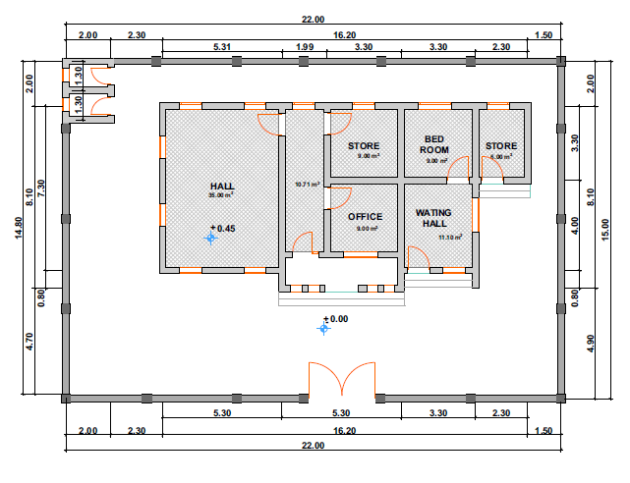

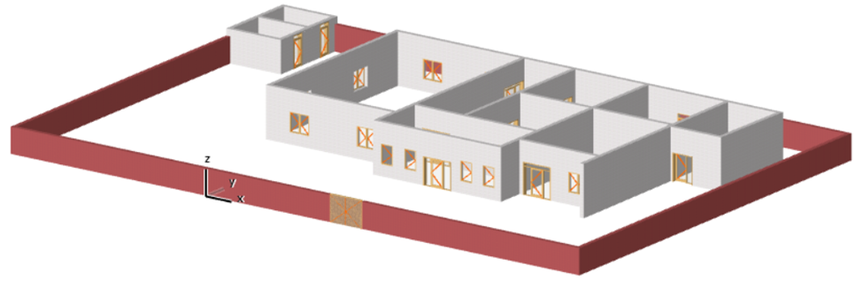

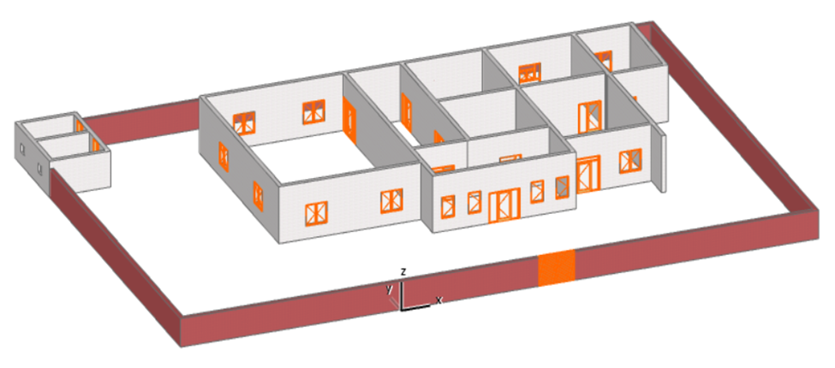

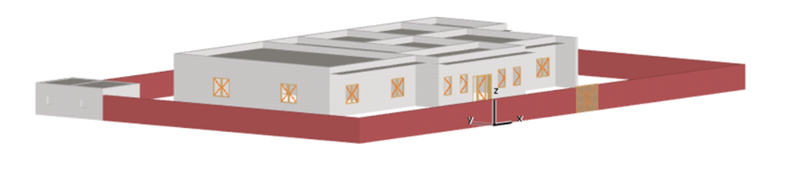

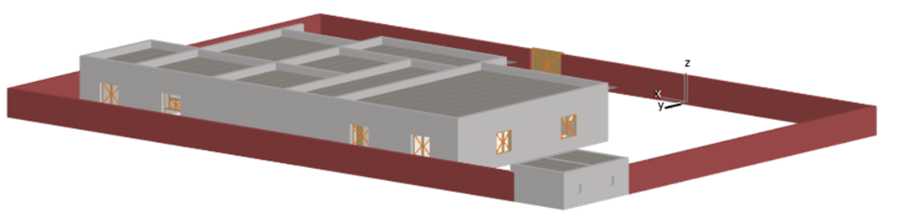

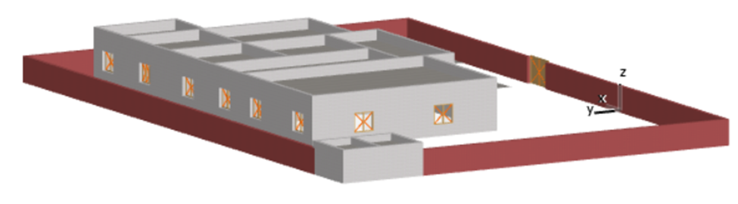

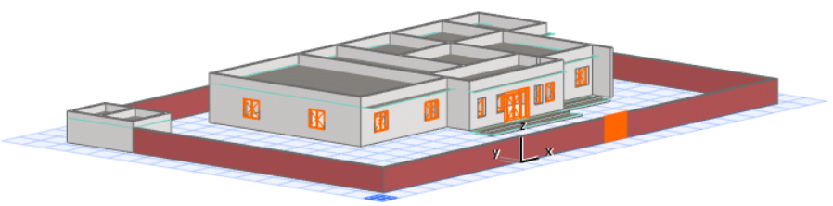

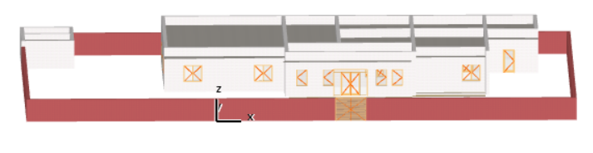
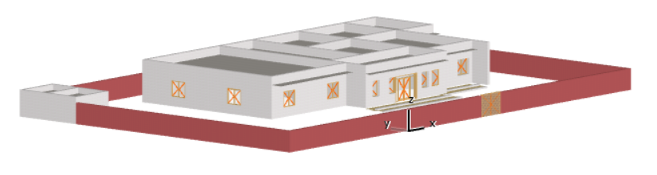

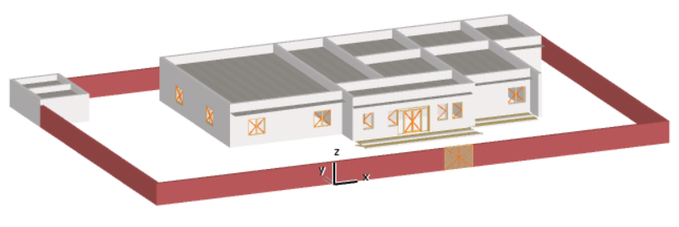

The supplier will be responsible of transportation. ARC will not pay separately for transportation

Vendor Confirmation |  | Vendor Stamp
Name:
Title:
Signature:
Date:

